

**IS203 Software Engineering Final Technical Documents**

**G6T3**

**Team Members:**

He Yongsheng Wilson

Tan Ming Kwang

Eugene Tan Wei Hong

Cristabel Lau Yuit Theng

Quek Yew Kit

**Use Case Diagram**

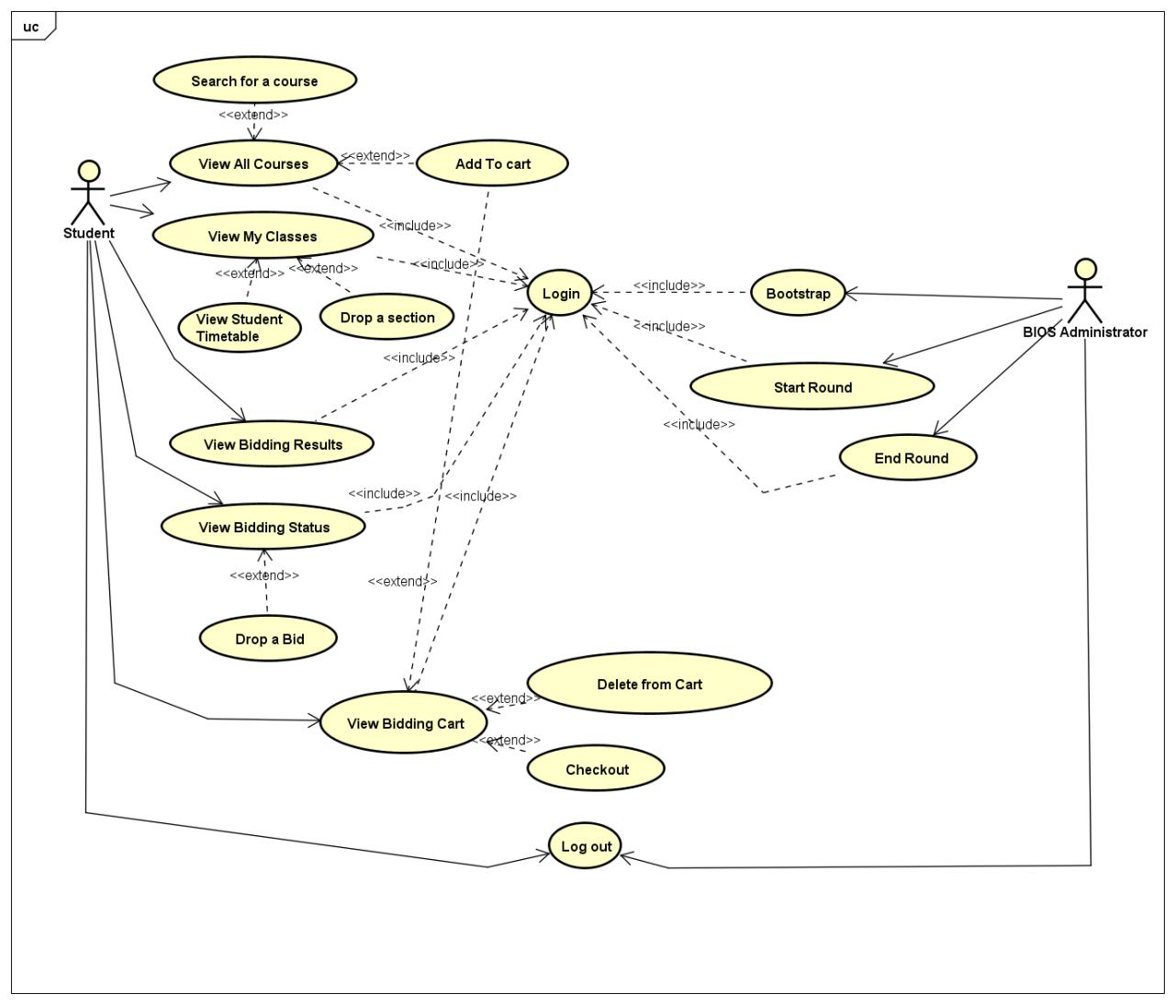

**Use Case Description**

**Bootstrap**:

* Insert data into the database. It will conduct validations and return the correct number of entries inserted, as well as the number of rows with errors

**Start Round / End round**:

* Admin feature. This feature allows admin to start and stop a round and trigger the system to perform round clearing logic to insert successful bids into database and vice versa.

**Login**:

* Administrator and students are required to log in to the system to continue accessing other functions

**Log Out**:

* Admin and student can terminate their session and exit the system.

**Search for a course**:

* Student is allowed to search for a course via Course code or course title and filter the results into a smaller list.

**View All courses**:

* Student can view all courses to bid for in current round. Round 1 sees pre filtering to only allow student to see and bid for own school courses only

**Add to cart**:

* Allows student to add bid for a particular section to shopping cart for review before checking out as a bid.

**View My Classes**:

* Student can view all enrolled sections for the upcoming semester after the round is closed.

**View Student timetable**:

* Student can view all enrolled courses schedules as part of a timetable format to allow easier reference.

**Drop a section**:

* Student can drop a particular section and be refunded full amount to re bid for another section of another module

**View Bidding results**:

* Student can view the results of a bidding round and all his/her bids when the round is closed, and even when round 2 is started in the homepage and in the view my classes page

**View Bidding status**:

* Student can view the bid status of all the bids placed.

**Drop a bid**:

* Student can drop his/her bids after placing his/her bids.

**View Bidding cart**:

* Allows student to see and review his bids before checkout collectively.

**Delete from Cart**:

* Allows student to drop a particular shopping cart item to add more items into their cart for checkout

**Checkout**:

* Allows student to check-out all the bids collectively for easier reference and review.

**Class Diagram**

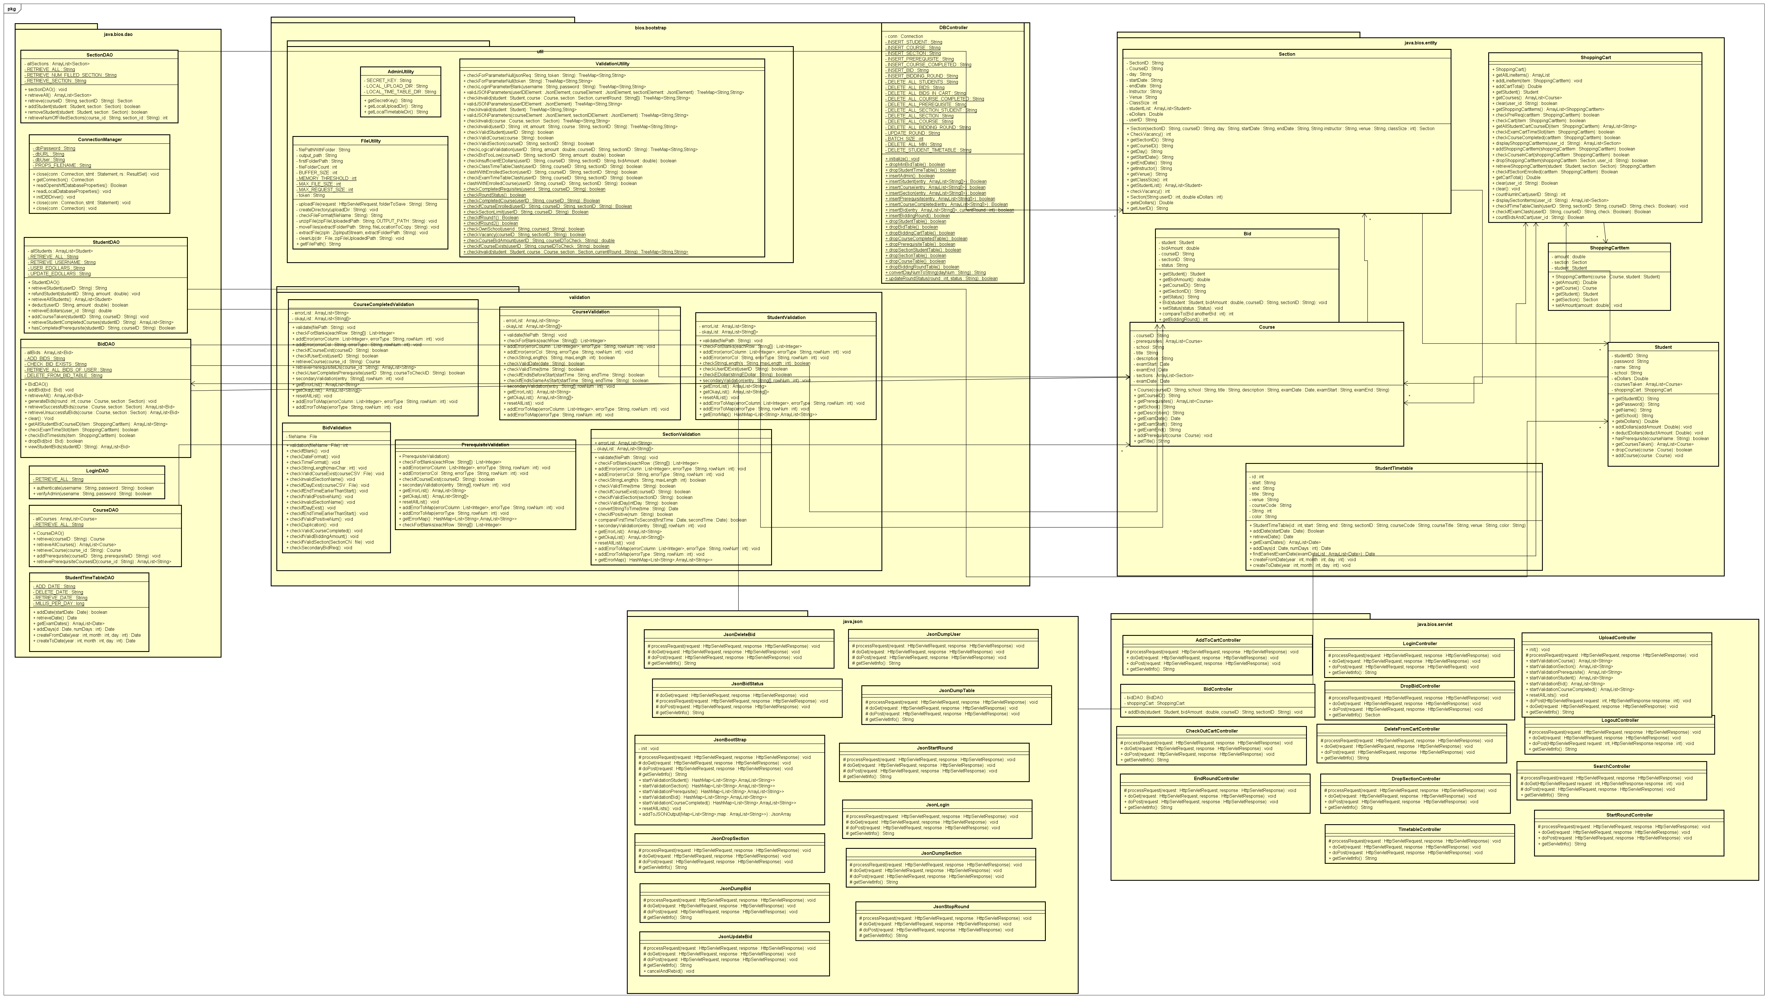

**Sequence Diagram**

**Login**



**Logout**



**View All Courses**



**Search for a course**



**Add to Cart**



**View My Classes**



**View Student Timetable**



**Drop a section**



**View Bidding results**



**View Bidding Status**

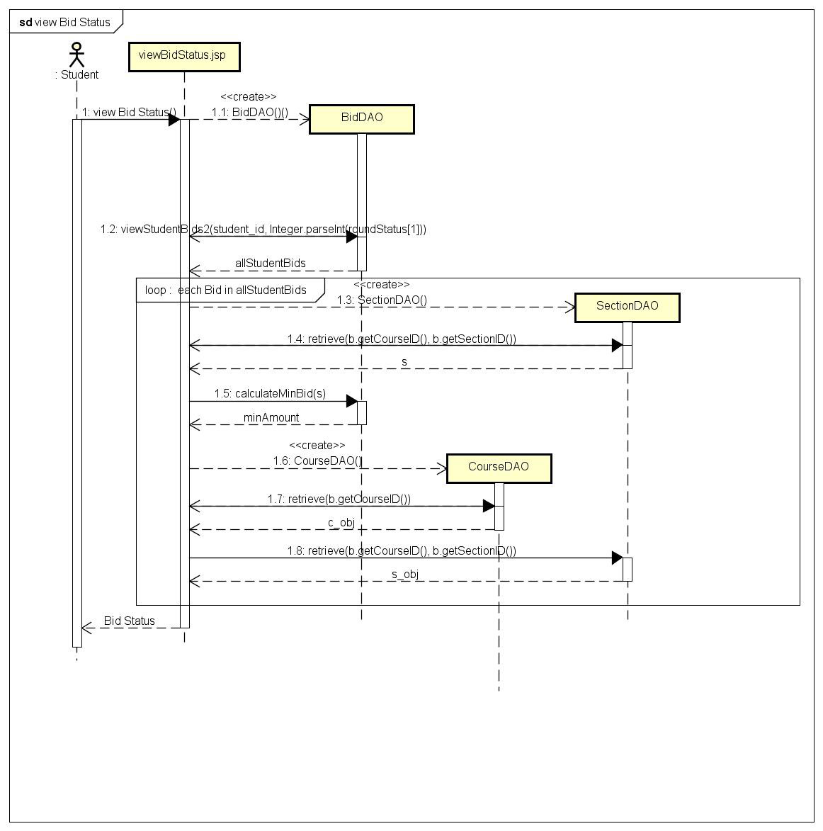

**Drop a Bid**



**View Bidding Cart**

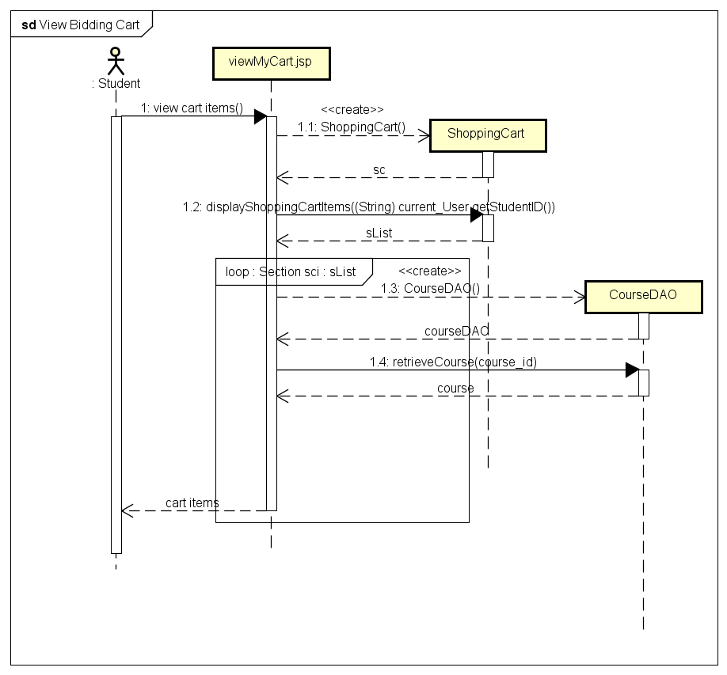

**Delete from Cart**

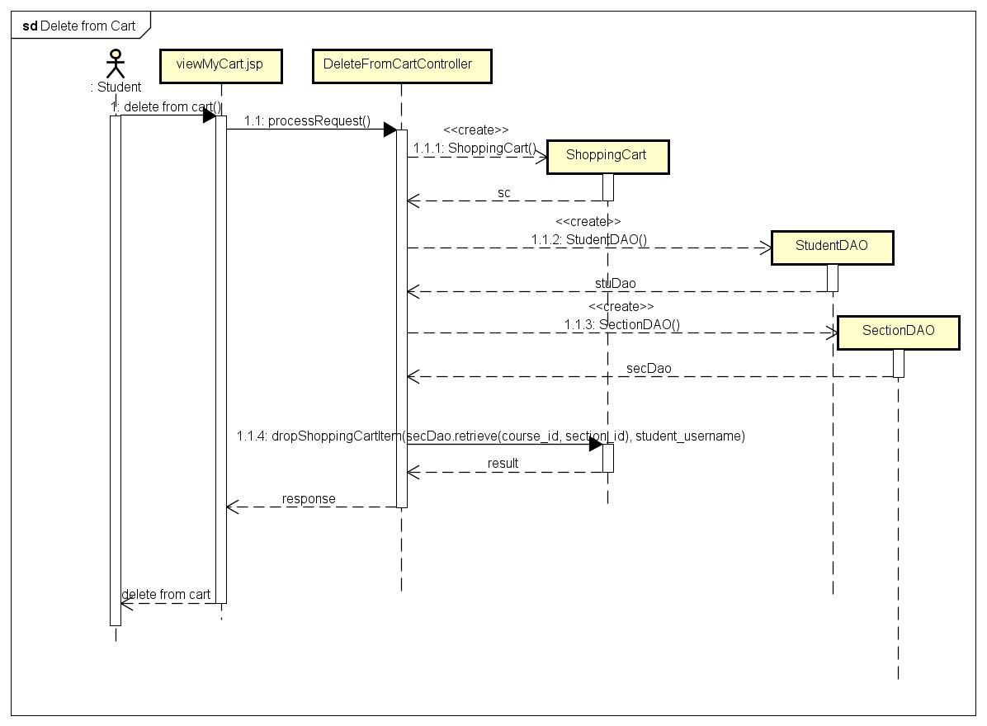

**Checkout**

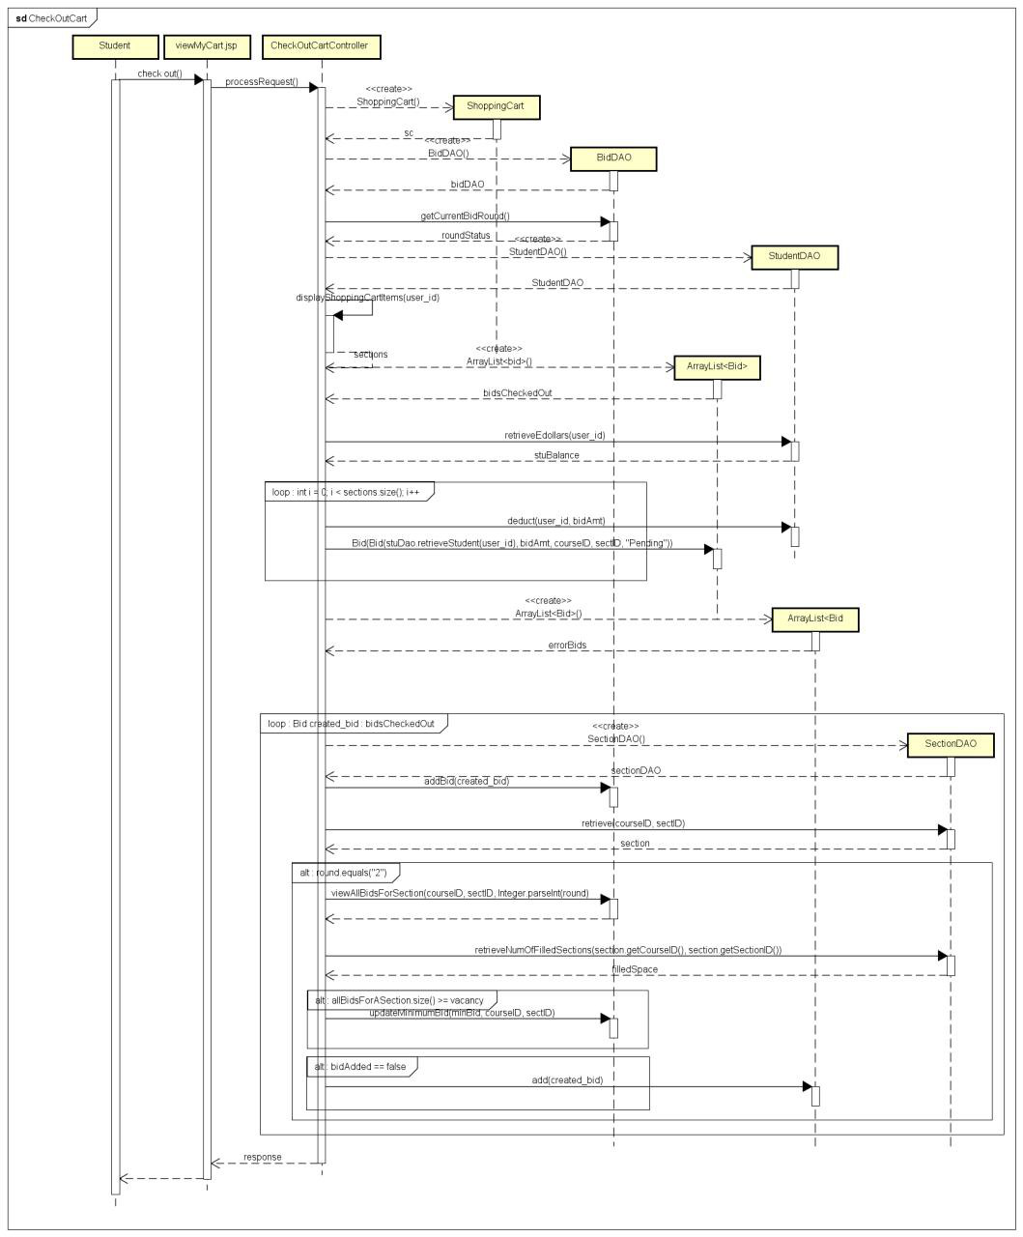

**Bootstrap**

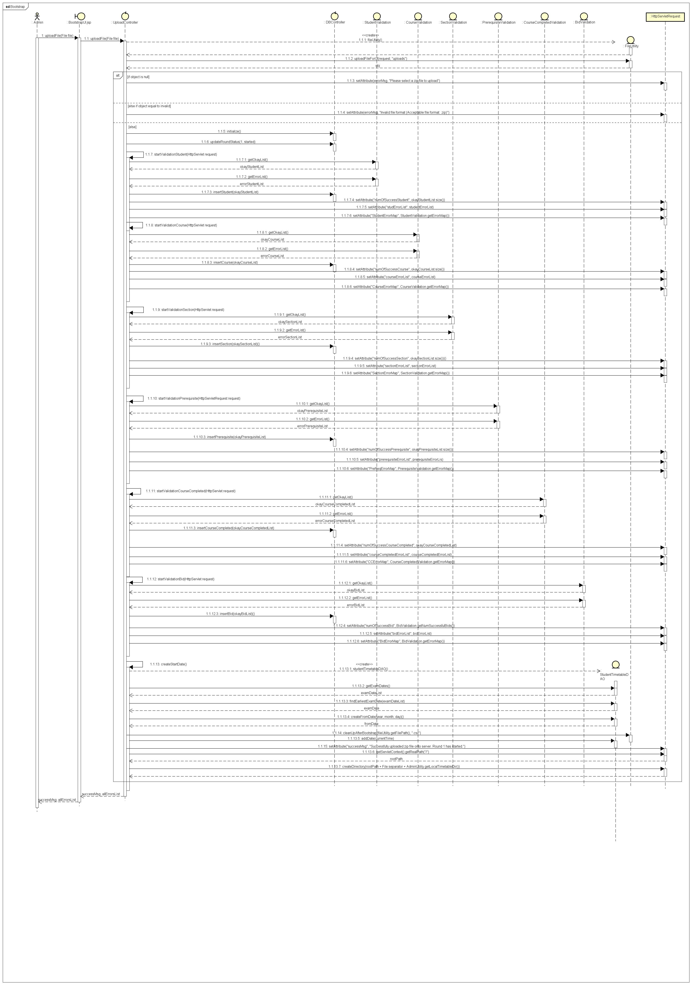

**Start Round**



**End Round**

